Objective
The objective of this project is to develop a Python-based Student Grade Calculator that accepts marks for multiple subjects and calculates the student's total marks and percentage. Based on predefined percentage conditions, the program assigns an appropriate grade. The project also focuses on practicing conditional statements, arithmetic operations, user input, and input validation.
Key Features
- Accepts marks for multiple subjects.
- Validates marks within the allowed range of 0–100.
- Calculates the total marks obtained.
- Calculates the overall percentage.
- Assigns grades based on predefined conditions:
  - A+ → 90% and above
  - A → 80–89%
  - B → 70–79%
  - C → 60–69%
  - D → 50–59%
  - E → 40–49%
  - F → Below 40%
- Displays the student's subject-wise marks.
- Displays the total, percentage, grade, and performance.
- Shows whether the student has passed or failed.
- Provides an interactive web interface using Streamlit.
- Can be executed locally using localhost.
Technologies Used
- Python – Main programming language used to develop the grade calculator.
- Streamlit – Used to create the interactive web-based interface.
- Conditional Statements (if, elif, else) – Used to assign grades based on percentage.
- Arithmetic Operations – Used to calculate total marks and percentage.
- Input Validation – Used to ensure that marks are within the valid range.
- Git & GitHub – Used for version control and project submission.
- Localhost – Used to run and test the Streamlit application locally. 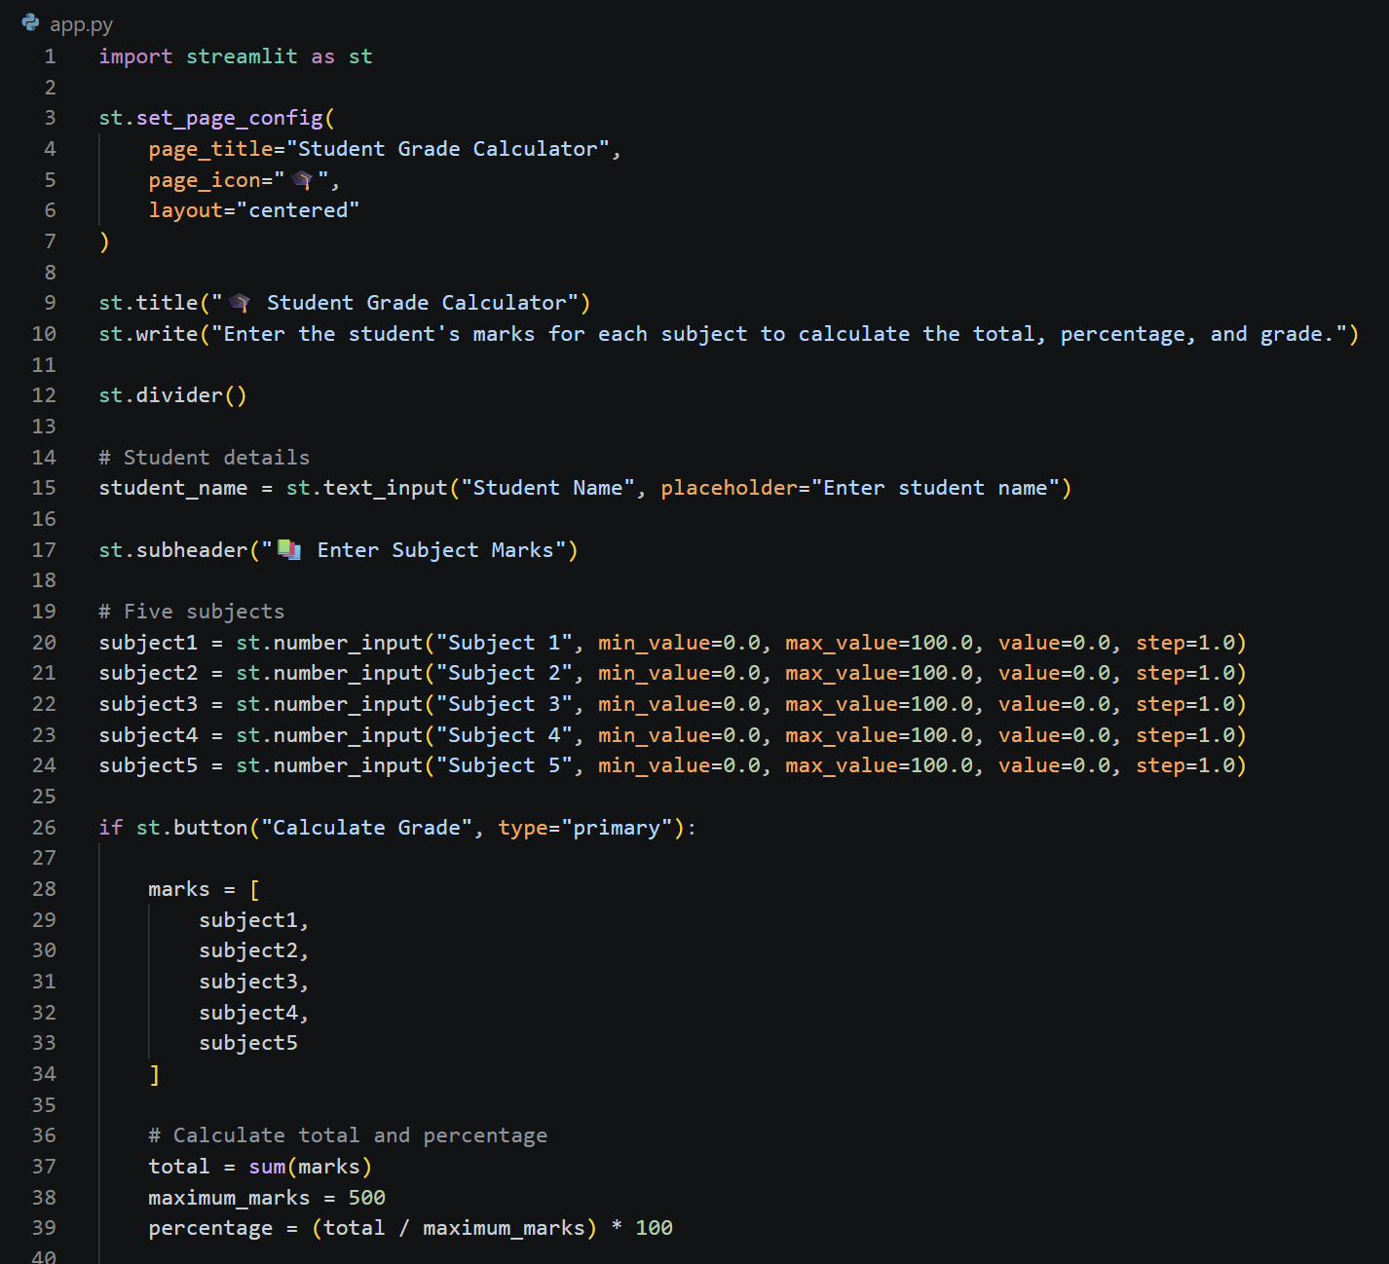
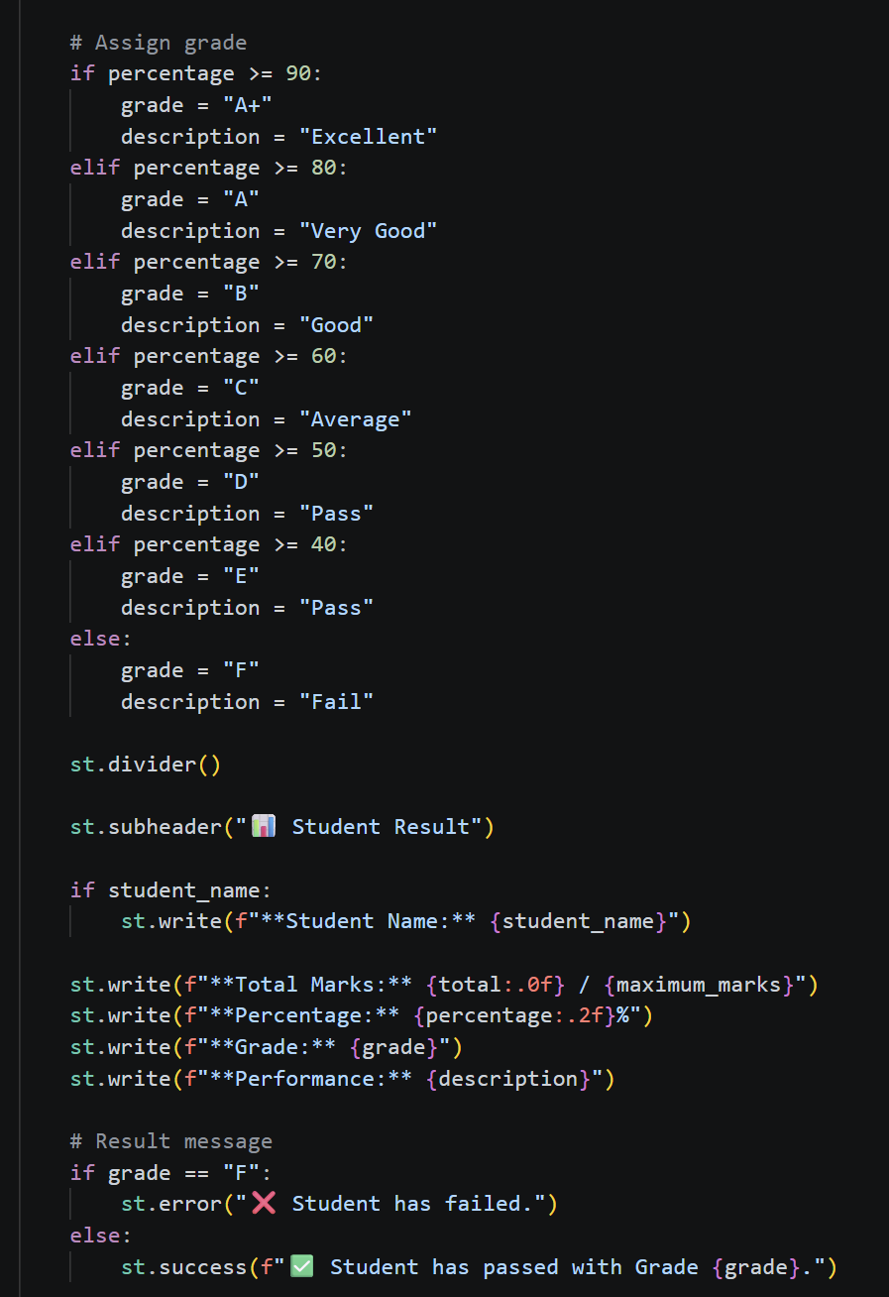
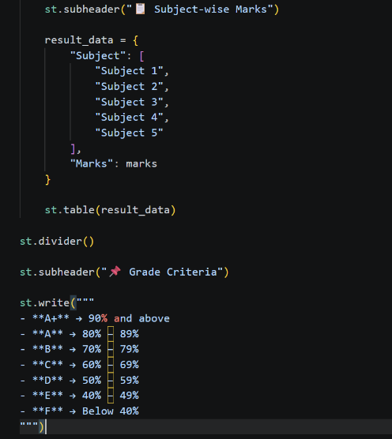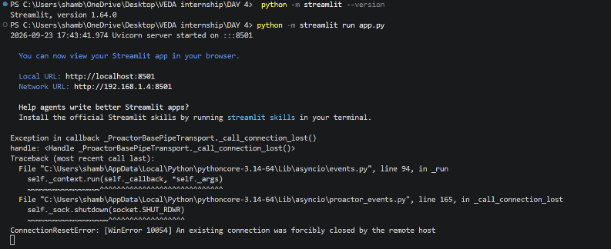

OUTPUT : http://192.168.1.4:8501
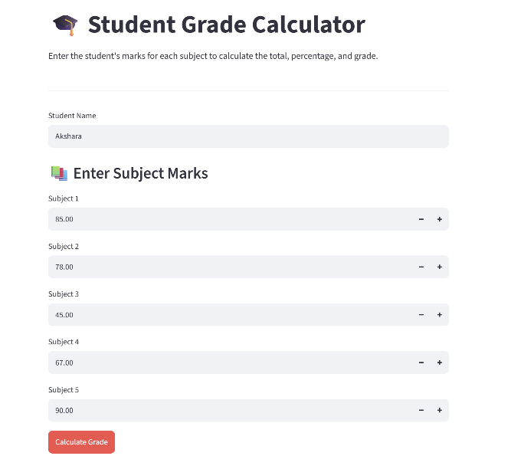
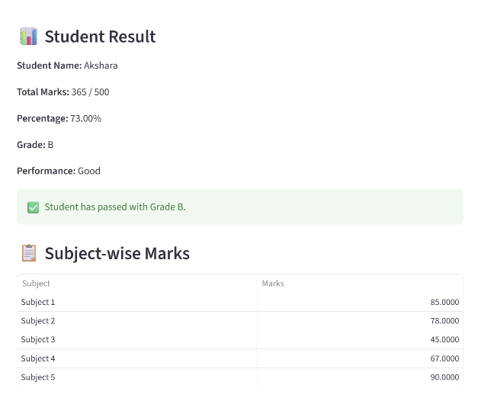
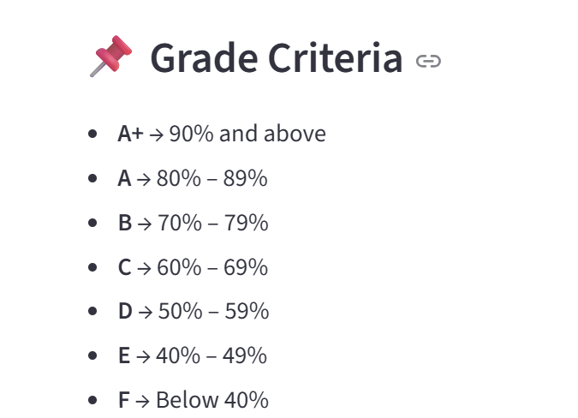

Github: https://github.com/shambhavi0804/VEDA-internship/commit/3e808d0cfc5ca670ea440104b2b7d7640e4a3c7f
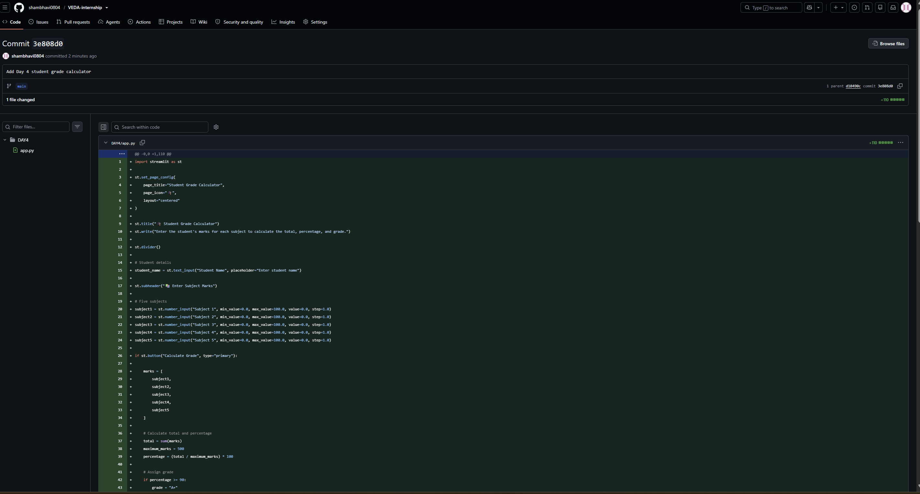
https://lnkd.in/p/dn_dCeZb
